# Ideation Phase

**Define the Problem Statements**

|  |  |
| --- | --- |
| Date | 10 September 2022 |
| Team ID | PNT2022TMID52856 |
| Project Name | Smart Farmer - IOT Enabled Smart Farming Application |
| Maximum Marks | 4 Marks |

## Problem Statement :

**Farmers can’t continuously monitor farm conditions and they have d**ifficulty in predicting suitable crop

variety that can be cultivated. They are unable to remotely control irrigation pumps according to the crop

water requirement. Hence, they are not able to produce maximum yield.

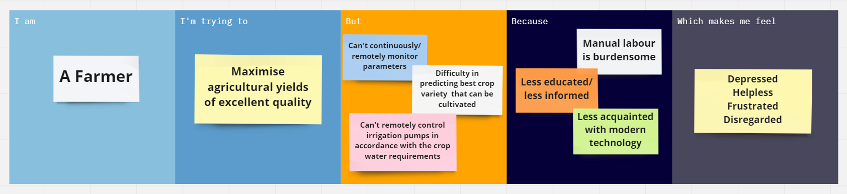

|  |  |  |  |  |  |
| --- | --- | --- | --- | --- | --- |
| **Problem**  **Statement (PS)** | **I am**  **(Customer)** | **I’m trying to** | **But** | **Because** | **Which makes me feel** |
| PS-1 | Farmer | Maximise agricultural yields of excellent quality. | * **Can't continuously/ remotely monitor parameters** * Difficulty in predicting best crop variety  that can be cultivated * Can't remotely control irrigation pumps in accordance with the crop water requirements | * Manual labour is burdensome * Less educated/ less informed * Less acquainted with modern technology | * Depressed * Helpless * Frustrated * Disregarded |